**Exercise Problem Lab 4**

1. **Draw 2 clusters similar to this**

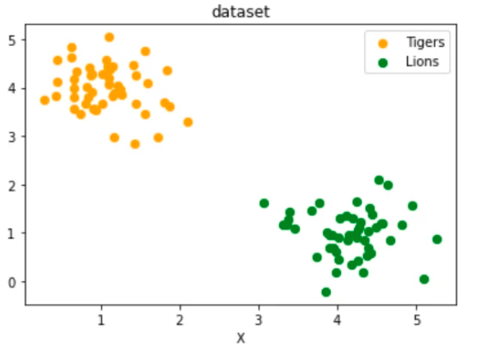

**2. Draw 2 clusters similar to this**

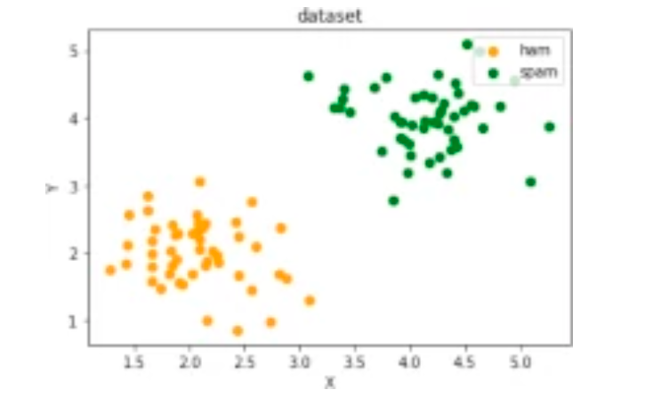

**3.Draw similar to this with 5 classes creating a dataset**

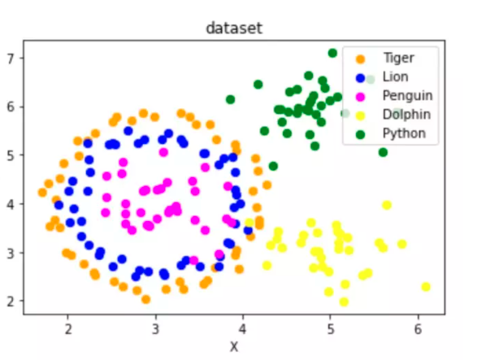

4. Using blobs draw similar to this

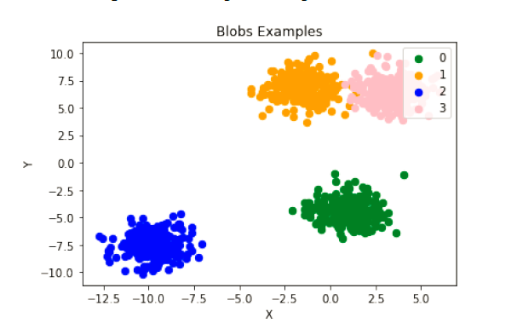

**5.using sklearn Fetch the Olivetti faces dataset and visualize the faces**

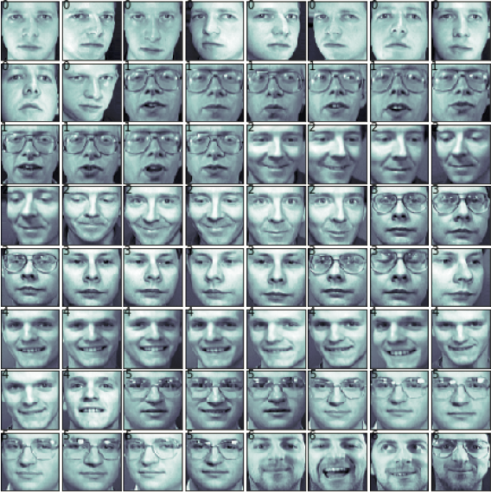

**6. Using SKLEARN explore iris dataset and perform 3 different operation**